**1.4**

**Android Hello World App Example**

By using android studio IDE (Integrated Development Environment) we can implement required android apps based on our requirements.

To implement android hello world app first we need to setup development environment using android studio IDE which is freely provided by Google for android developers. In case if you are not aware of how to setup android development environment, follow step by step [Android Environment Setup](https://www.tutlane.com/tutorial/android/android-studio-installation-for-development-environment) tutorial.

Once we are done with [Android Studio Installation](https://www.tutlane.com/tutorial/android/android-studio-installation-for-development-environment), open android studio and that will be like as shown below.

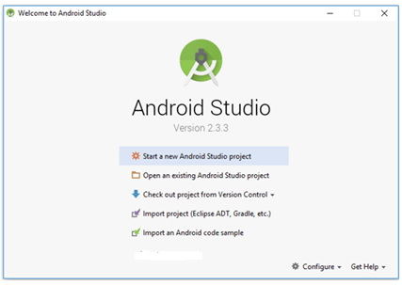

Here we're going to choose the **New Project** option because we haven’t created any other project and we need to create a new one. So, we will select the New Project from the given options.

However, we can choose **Import Project** if we’d like to import a project from any other way, for example, Eclipse project into Android Studio. Android Studio will convert the Eclipse project to an Android Studio project, adding the necessary configuration files for us.

If we select **Open Project** from the list of options, we can open projects created with either Android Studio or IntelliJ IDEA.

Check out from Version Control, we can check out a copy of a project that's under version control. This is a great way to quickly get up to speed with an existing project.

To get us started, choose **New Project** from the list of options. This will show us a list of options to configure our new project.

As we click on “**New Project**” from the above option, then the next screen will be open like this, where we have to mention our **Project’s name**, **Company domain** and **Project location** (we called it the main path where this application will be save) because the **Package name** will be created automatically as we create the project in Android Studio.

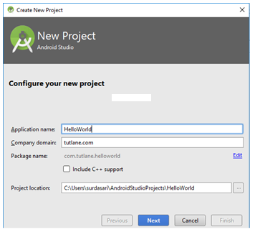

After entering all the details if we click on “**Next**” button another screen will be appear where we have select the different platforms and SDK targets like as shown below based on our requirements.

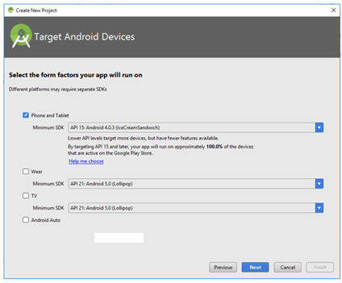

Here we need to select the type of Platform which we are going to use for the Application development like if we select “**Phone and Tablet**”, then it will show it’s different **API** and **SDK** version and similarly to others.

If we choose “**Wear**”, then it will show it’s API and SDK versions like as shown below.

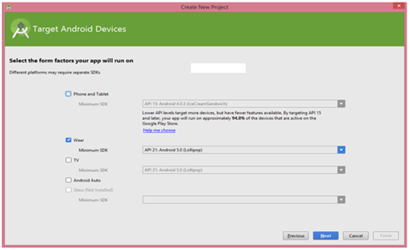

In case if we choose “**TV**”, then it will show it’s API and SDK versions like as shown below.

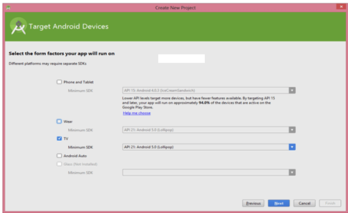

**Wear**: We use this option for **Android Watches** which we can wear to our hand and use the same functionality as we do with the Android devices. We can call, set the alarm, capture images and many more things easily.

**TV**: We use this option for **SmartIPTV** which is very much common these days. We can see our favorite channels like we see in our Home Televisions and make the changes in the channel easily.

Here we are going to implement app for phone and tablets, so we selected a **Phone and Tablet** option and click “**Next**” and it will install required components like as shown below.

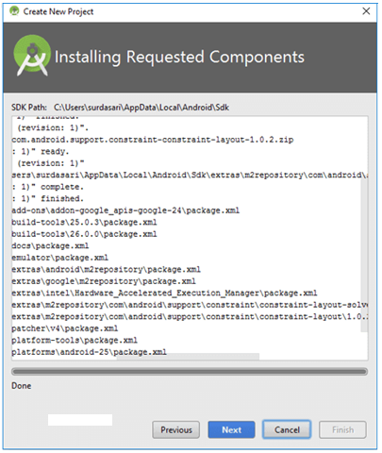

Now click **Next** to select the particular Activity for our requirement. If we will select the “**Empty Activity**”, then it will show the empty activity in our layout. In case if we choose other options, then it will show the activity which we have chosen. Here we are selecting **Empty Activity** like as shown below.

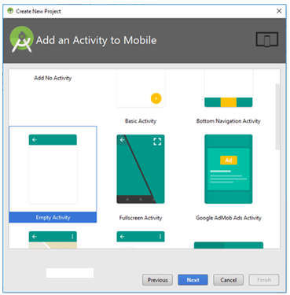

After choosing the “**Activity**” for our application, then click on the “**Next**” button and it will take us to the next screen like as shown below.

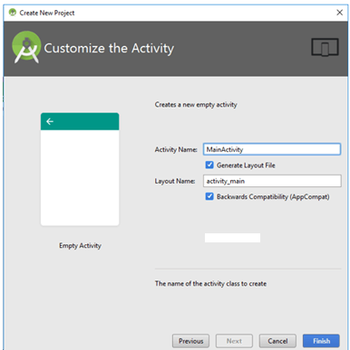

Here we can see that the Activity i.e. **EmptyActivity** which we selected in previous section and the java file name i.e. “**MainActivity**”. Now we are ready for final step, just click on “**Finish**” button and it will took us to the Main page where we have to do the coding and create new layouts over there.

After clicking **Finish**, we will be presented with Android Studio's user interface with the project explorer on the left and the workspace on the right like as shown below.

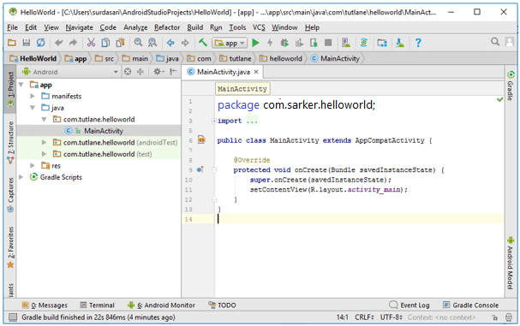

Following are the important files which we need to build our app in android studio.

**Android Layout File (activity_main.xml)**

The UI of our application will be designed in this file and it will contain **Design** and **Text** modes. It will exists in **layouts** folder and the structure of **activity_main.xml** file in **Design** mode like as shown below.

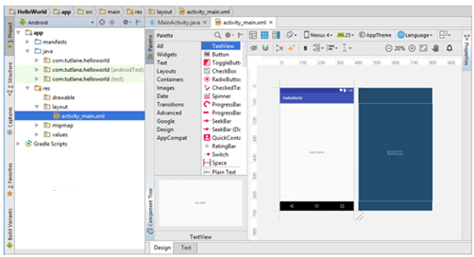

 We can make a required design modifications in **activity_main.xml** file either using **Design**

or **Text** modes. If we switch to **Text** mode **activity_main.xml** file will contain a code like as shown below.

<?xml version="1.0" encoding="utf-8"?>  
<android.support.constraint.ConstraintLayout xmlns:android="http://schemas.android.com/apk/res/android"  
    xmlns:app="http://schemas.android.com/apk/res-auto"  
    xmlns:tools="http://schemas.android.com/tools"  
    android:layout_width="match_parent"  
    android:layout_height="match_parent"  
    tools:context="com.sarker.helloworld.MainActivity">  
    <TextView  
        android:layout_width="wrap_content"  
        android:layout_height="wrap_content"  
        android:text="Hello World!"  
        app:layout_constraintBottom_toBottomOf="parent"  
        app:layout_constraintLeft_toLeftOf="parent"  
        app:layout_constraintRight_toRightOf="parent"  
        app:layout_constraintTop_toTopOf="parent" />

</android.support.constraint.ConstraintLayout>

**Android Main Activity File (MainActivity.java)**

The main activity file in android application is **MainActivity.java** and it will exists in **java** folder. The **MainActivity.java** file will contain the java code to handle all the activities related to our app.

Following is the default code of **MainActivity.java** file which is generated by our **HelloWorld**

application.

package com.sarker.helloworld;  
import android.support.v7.app.AppCompatActivity;  
import android.os.Bundle;  
public class MainActivity extends AppCompatActivity {  
    @Override  
    protected void onCreate(Bundle savedInstanceState) {  
        super.onCreate(savedInstanceState);  
        setContentView(R.layout.activity_main);  
    }  
}

**Android Manifest File (AndroidManifest.xml)**

Generally our application will contain multiple **activities** and we need define all those **activities** in **AndroidManifest.xml** file. In our manifest file we need to mention the main activity for our app using **MAIN** action and **LAUNCHER** category attributes in **intent filters** (<intent-filter>). In case if we didn’t mention MAIN action or LAUNCHER category for main activity, our app icon will not appear in home screen’s list of apps.

Following is the default code of **AndroidManifest.xml** file which is generated by our **HelloWorld** application.

<?xml version="1.0" encoding="utf-8"?>  
<manifest xmlns:android="http://schemas.android.com/apk/res/android"  
    package="com.sarker.helloworld" >  
    <application  
        android:allowBackup="true"  
        android:icon="@mipmap/ic_launcher"  
        android:label="@string/app_name"  
        android:roundIcon="@mipmap/ic_launcher_round"  
        android:supportsRtl="true"  
        android:theme="@style/AppTheme" >  
        <activity android:name=".MainActivity" >  
            <intent-filter>  
                <action android:name="android.intent.action.MAIN" />  
                <category android:name="android.intent.category.LAUNCHER" />  
            </intent-filter>  
        </activity>  
    </application>  
</manifest>

**Run Android Hello World App**

To run android applications we need to click on **Run** button or press Shift + F10 like as shown below:

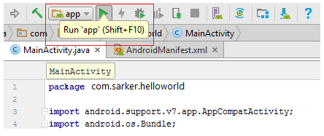

After click on play button new window will open in that select **Android Virtual Device** (AVD) and click **OK** like as shown below.

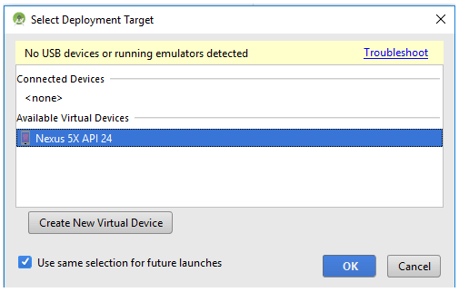

Now our android hello world application will show the result like as shown below

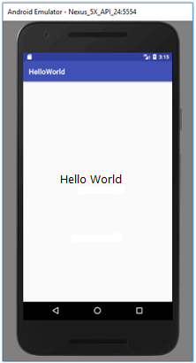

In our **AndroidManifest.xml** file we mentioned MAIN action and LAUNCHER category attributes for our main activity file due to that our app icon will create in Home screen list of apps like as shown below.

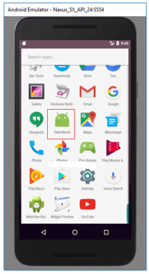

This is how we can create an apps in android and execute applications based on our requirements.

**Questions**

1. What is for AndroidManifest.xml file? Write necessary code for AndroidManifest.xml.
2. What is for MainActivity.java file? Write necessary code for MainActivity.java file.
3. What is for activity_main.xml file? Write necessary code for activity_main.xml file.
4. What are the two modes of UI and why they are for?
5. Write the meaning of the following:
6. android:layout_width="match_parent"
7. android:layout_height="match_parent"